SIMATS ENGINEERING
ASSESSMENT TOOL 3
APPLICATION-BASED QUESTIONS
Course: Cloud Computing and Big Data Analytics
Course Code: CSA15
Course Outcome: CO2 – Analyze virtualization architectures to identify performance and security issues in cloud computing environments
Total Marks: 25
Student Name: M. Akhil kumar
Register Number: 192572060

Question 1: Auto-Scaling and Load Balancing During Seasonal Sales

Introduction
An e-commerce company may receive a sudden increase in visitors during festival sales, flash sales, or special promotions. If its servers cannot handle the extra requests, pages become slow or the website may become unavailable. Cloud auto-scaling and load balancing help the company respond to changing demand.

How Auto-Scaling Handles Traffic Spikes
Auto-scaling automatically increases or decreases the number of application server instances according to demand or configured metrics such as CPU utilization, request count, or response time. During a sale, additional instances can be started to process more requests. When traffic falls, unnecessary instances can be removed to reduce cost.

Role of Load Balancing
A load balancer distributes incoming requests across healthy server instances. It prevents one server from becoming overloaded and can stop sending traffic to an unhealthy instance. This improves response time and helps the service remain available when a server fails.

Monitoring, Downtime and User Experience
Monitoring tools collect metrics, logs, and alerts. They help operators identify rising demand, slow responses, errors, and resource bottlenecks. Scaling policies can use these metrics to add capacity before the service becomes overloaded. Health checks and automated recovery reduce downtime, while faster page loads and fewer failed checkouts improve customer experience.

Real-World E-Commerce Example
During a major festival sale, an online retailer may experience several times its normal traffic. The monitoring system detects increased request volume, auto-scaling launches more web and application instances, and the load balancer distributes shoppers across them. After the sale, the extra instances are scaled down. The company can serve more customers without permanently paying for peak capacity.
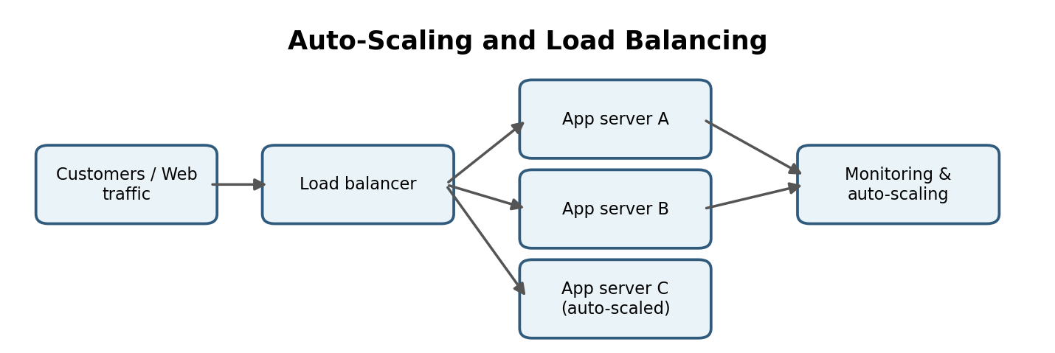
Figure 1. Auto-scaling and load balancing workflow.

Additional Benefits of Auto-Scaling
Auto-scaling can be configured with minimum, maximum, and desired capacity limits. A minimum capacity keeps essential services running, while a maximum limit helps control unexpected spending. Scheduled scaling can prepare for predictable events such as a festival sale, and dynamic scaling can respond to sudden changes. A cooldown or stabilization period helps prevent repeated rapid increases and decreases in server count.

Important Design Considerations
Auto-scaling works best when application instances are designed to be replaceable and do not depend on local server storage for important user data. Session information can be stored in a shared service, and deployments should be tested under realistic loads. Teams should also configure alerts for failed health checks, scaling limits, database saturation, and unusual cost increases. Scaling web servers alone may not solve a bottleneck in the database or payment gateway.

Key Benefits
The combined approach improves availability, supports smoother checkout during peak demand, and reduces the need to purchase enough physical servers for the highest possible traffic. It also gives the operations team measurable information for capacity planning and future improvements.

Question 2: Secure and Cost-Effective Cloud Backup Storage

Durability and Data Redundancy
Cloud storage services are designed to keep data available over time. Durability is improved by storing redundant copies across separate disks, devices, or facilities, depending on the selected service. Replication and integrity checks help protect against hardware failure or accidental loss. For critical backups, an organization can keep copies in a separate region and maintain versioning.

Encryption and Access Control
Encryption in transit protects data while it is uploaded or downloaded, typically using TLS. Encryption at rest protects stored backup files. Keys should be managed securely and rotated according to policy. Identity and access management (IAM), least-privilege permissions, multi-factor authentication, and separate backup administrator accounts reduce the risk of unauthorized access or deletion. Audit logs help track access and changes.

Cost Advantages Compared with Traditional Storage
Cloud backup can reduce upfront spending on storage hardware, backup servers, physical space, power, cooling, and maintenance. Organizations can pay for the capacity they use and select lower-cost archival tiers for data that is rarely accessed. Costs still depend on storage volume, retrieval, data transfer, retention, and redundancy settings, so lifecycle policies and periodic cost reviews are important.

Disaster Recovery Example
Suppose a company’s main office is affected by a flood or ransomware incident. Encrypted backups stored in a separate cloud region can be used to restore databases and business files to a clean environment. The organization should test restoration regularly, keep recovery instructions offline or protected, and define recovery time and recovery point objectives.
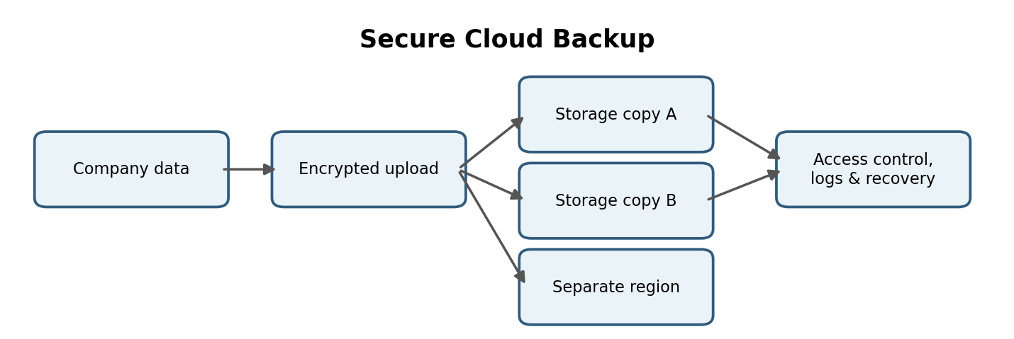
Figure 2. Redundant, encrypted cloud backup design.

Backup Strategy and Recovery Testing
A reliable backup plan should define what data is backed up, how frequently backups run, how long copies are retained, and who can restore them. The recovery point objective (RPO) describes the maximum acceptable amount of data loss measured in time. The recovery time objective (RTO) describes the target time for restoring a service. Regular restore drills verify that backup files are complete and that staff know the recovery process.

Shared Responsibility
Cloud providers maintain the underlying storage infrastructure, but customers remain responsible for many choices, including retention settings, permissions, encryption configuration, and whether backups are protected from accidental deletion. Immutable or write-once retention options, where available and correctly configured, can make it harder for an attacker to alter backup copies.

Cost and Performance Trade-Offs
Frequently accessed backups may need a standard storage tier, while older archives may fit a lower-cost tier with longer retrieval times. Keeping multiple copies improves resilience but increases storage costs. A practical policy balances recovery requirements, retention obligations, and budget, and it periodically removes expired copies according to the approved policy.

Question 3: Global Application Performance Using CDNs and Edge Servers

How a CDN Reduces Latency
A content delivery network (CDN) is a distributed network of servers that caches copies of content closer to users. Static assets such as images, video segments, style sheets, and scripts can be delivered from a nearby edge location instead of always travelling to the origin server. This reduces network distance, origin load, and often page or media loading time.

Edge Servers and User Experience
Edge servers serve requests near users and may perform caching, request routing, or selected computing tasks. Users in different regions can receive content from nearby locations, improving responsiveness and reducing buffering. Dynamic requests that cannot be cached may still need to reach the application origin, so CDN configuration and application architecture both matter.

Global Availability from Cloud Providers
Cloud providers operate regions and availability zones in multiple geographic areas. Deploying services across suitable regions, using health checks and traffic routing, and replicating required data can improve resilience. A CDN complements this architecture by distributing content worldwide. The organization should consider data residency, latency, cost, and disaster recovery when choosing regions.

Streaming or Gaming Example
A live-streaming application can deliver video segments through edge locations so viewers in India, Europe, and North America receive content from nearby servers. For online gaming, a nearby game server or edge service can reduce round-trip time; a CDN can deliver game updates and static assets. Real-time game state usually requires careful server placement and cannot be made low-latency by caching alone.
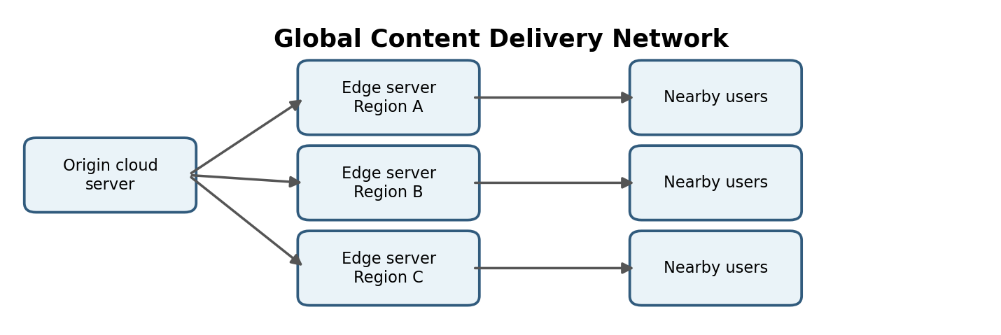
Figure 3. CDN edge locations serve users in multiple regions.

CDN Caching and Cache Management
A CDN checks whether a requested object is already available at an edge location. If it is cached and still valid, the edge server can return it quickly. If not, the CDN fetches the object from the origin and may cache it for future requests. Cache-control headers, time-to-live settings, and cache invalidation help keep content current. Personalized account pages and sensitive transaction responses should not be publicly cached; caching rules must be designed carefully.

Availability and Resilience
A globally deployed service should avoid depending on a single region or origin for every request. Health checks, redundant origins, regional failover, and replicated application components can help maintain service during an outage. These features require testing: failover may not work as intended if data is not replicated, DNS changes take time, or application dependencies remain in the failed region.

Performance Measures
Teams can assess CDN effectiveness using latency, cache-hit ratio, origin request volume, error rate, and video rebuffering metrics. They can compare performance from multiple regions and tune cache rules based on real usage. For interactive applications, edge delivery should be combined with efficient APIs and suitable regional application placement.

Question 4: Regulatory Compliance and Security in Cloud Financial Services

Compliance Support and Auditing
Cloud providers offer security and compliance capabilities such as identity management, encryption services, audit logs, policy controls, and compliance reports or certifications for eligible services. These capabilities can support an institution’s compliance program, but using a compliant cloud service does not automatically make the customer compliant. The institution must configure services correctly and meet its own legal and operational obligations.

Logging, Monitoring and Encryption
Logs record events such as sign-ins, permission changes, API calls, and access to sensitive resources. Centralized monitoring can detect unusual activity and generate alerts. Logs should be protected from tampering, retained according to policy, and reviewed regularly. Encryption in transit and at rest protects sensitive information; secure key management and strict access permissions are essential.

Data Sovereignty and Residency
Data sovereignty requirements may restrict where data is stored, processed, or accessed. The institution should identify applicable laws and regulator requirements, select approved cloud regions, configure storage and backup locations accordingly, and review provider terms and subcontractors. It should also examine cross-border support access, disaster-recovery replication, and deletion/retention rules.

Financial Transaction Example
For a digital banking application, access to transaction records can be limited to authorized services and staff roles. Encryption protects records in storage and during transfer, while audit logs record administrative and application activity. Alerts can flag unusual access or repeated failed login attempts. Compliance teams can review logs and configuration evidence during audits, while transaction data remains in approved locations.
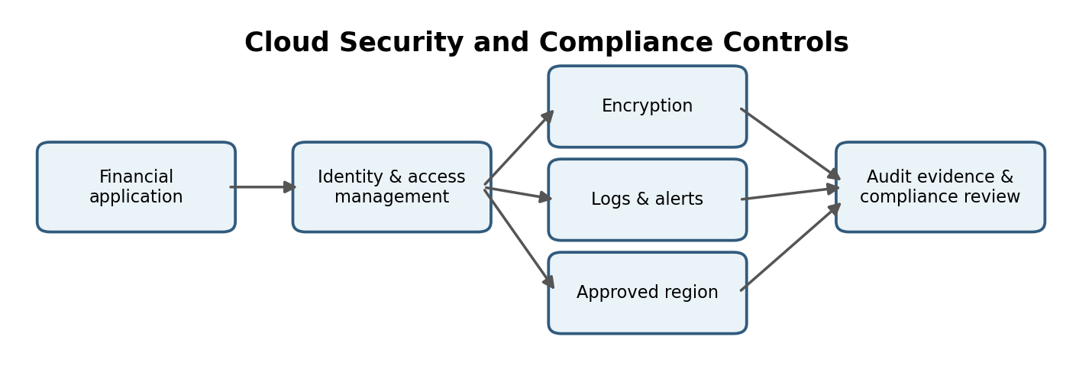
Figure 4. Security and compliance controls for a financial application.

Shared Responsibility and Risk Management
A financial institution should map each applicable regulation and internal policy to technical controls and evidence. It should maintain an inventory of sensitive data, define who owns each control, and review configuration changes. Provider audit reports can help with due diligence, but the institution should confirm that the specific services and regions it uses are within the scope of the relevant report or certification.

Audit Readiness
Audit records should include timestamps, actor identity, the action performed, the affected resource, and the outcome where available. Time synchronization, restricted log access, retention rules, and protected central storage make records more useful. Security teams can use alerting and incident-response procedures to investigate suspicious events and preserve evidence. Access should be reviewed periodically, especially for privileged accounts.

Data Sovereignty in Practice
Selecting a local region is only one part of data sovereignty. The organization should also review where replicas and backups are stored, where logs are processed, which support teams can access data, and whether third-party services move data across borders. Contractual commitments, technical configuration, and periodic audits should work together to demonstrate compliance.

Question 5: Containerization, Virtual Machines and Orchestration

Containers Compared with Virtual Machines
A virtual machine (VM) virtualizes hardware and usually runs its own guest operating system. A container packages an application and its dependencies while sharing the host operating-system kernel. Because containers generally have less overhead and start faster, more containerized workloads can often run on the same host. VMs provide a stronger separate operating-system boundary and can run different operating systems on one physical host. Both approaches require appropriate security configuration.

How Kubernetes Simplifies Deployment and Scaling
Kubernetes is a container orchestration platform. It can schedule containers across a cluster, restart failed workloads, maintain a desired number of replicas, support service discovery and load distribution, and perform rolling updates. Horizontal scaling can increase or decrease replicas based on configured needs. Teams still need to configure resource limits, access controls, monitoring, storage, and network policies.

Portability Across Cloud Environments
Container images package application code and dependencies in a consistent format. This helps teams build and test an application once and run it in different environments that support the required container runtime. Kubernetes provides a common orchestration interface across many platforms, although differences in networking, storage, identity, and managed services may require configuration changes.

Microservices Example
An online shopping platform may run separate product-catalogue, customer-account, payment, inventory, and order services in containers. Kubernetes can maintain multiple replicas of busy services and restart failed containers. The payment service should have strict network permissions and secrets management because it handles sensitive data. Independent services can be updated separately, provided their APIs remain compatible.
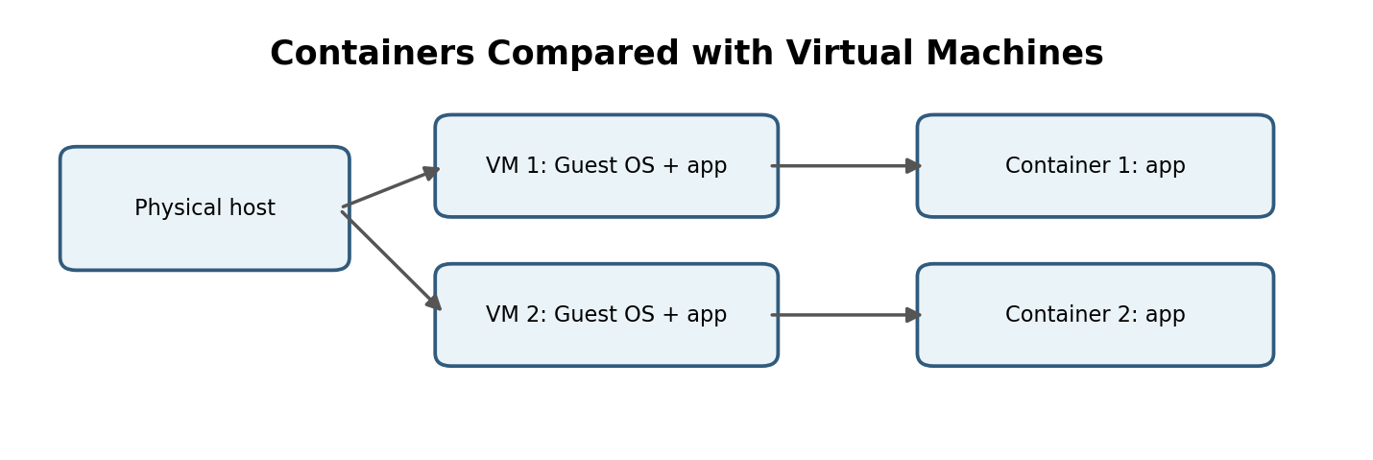
Figure 5. Simplified conceptual comparison of VM and container workloads.

Container Image and Cluster Security
Container images should come from trusted sources, be scanned for known vulnerabilities, and be rebuilt regularly with updated dependencies. Secrets such as passwords and API keys should be supplied through a secure secret-management mechanism rather than embedded in an image. Role-based access control, network policies, resource limits, and audit logs help reduce risk in a Kubernetes cluster.

Deployment and Operational Practices
Teams can use automated build and deployment pipelines to test images before release. Readiness checks help route traffic only to containers that are ready, while liveness checks can identify containers that need restarting. Rolling updates reduce disruption, and rollback plans help recover from faulty releases. Monitoring should cover application health as well as CPU, memory, storage, and network usage.

VMs and Containers Can Be Used Together
Containers do not eliminate the need for virtual machines. In many cloud environments, containers run on virtual machines managed by the cloud provider or the organization. VMs provide an infrastructure isolation layer, while containers package and manage application workloads. The appropriate design depends on security boundaries, workload requirements, operating-system needs, and operational skills.

